1. Grade Checker
Take a score as input and print the grade based on the following:
90+ : "A"
80-89 : "B"
70-79 : "C"
60-69 : "D"
Below 60 : "F"
here we used a basic if else statement to carry out marks and all.
Solution:
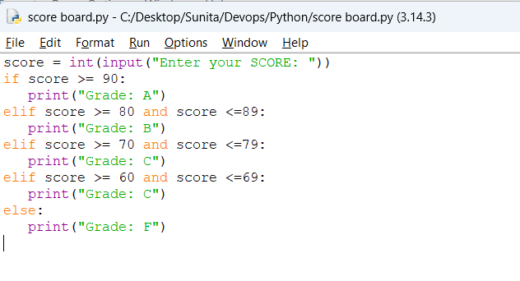
Output:
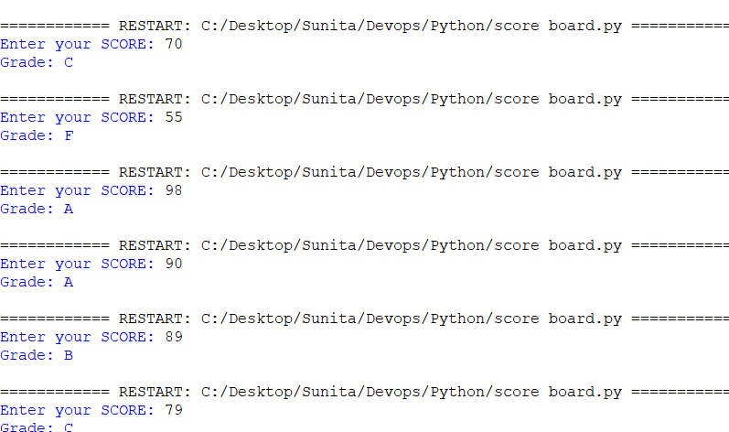

2 Student Grades
Create a dictionary where the keys are student names and the values are their grades. Allow the user to:
Add a new student and grade.
Update an existing student’s grade.
Print all student grades.
Solution:
Basic coding:
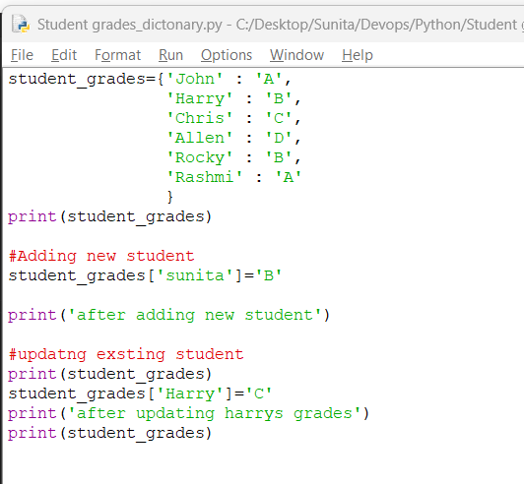
Output:
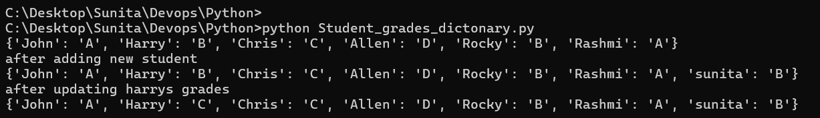

Used dictionary and basic operations. Using if else:
Program code:
# Create an dictionary to store student grades
student_grades = {'John' : 'A',
'Harry' : 'B',
'Chris' : 'C',
'Allen' : 'D',
'Rocky' : 'B',
'Rashmi' : 'A'}

while True:
print("\nChoose an option:")
print("1. Add a new student and grade")
print("2. Update an existing student's grade")
print("3. Print all student grades")
print("4. Exit")

choice = input("Enter your choice (1-4): ")

if choice == "1":
name = input("Enter student name: ")
grade = input("Enter grade: ")

if name in student_grades:
print("Student already exists!")
else:
student_grades[name] = grade
print("Student added successfully.")

elif choice == "2":
name = input("Enter student name to update: ")

if name in student_grades:
grade = input("Enter new grade: ")
student_grades[name] = grade
print("Grade updated successfully.")
else:
print("Student not found!")

elif choice == "3":

print("\n--- Student Grades ---")
print(student_grades)

elif choice == "4":
print("Exiting program. Goodbye!")
break

else:
print("Invalid choice. Please enter a number from 1 to 4.")

output:

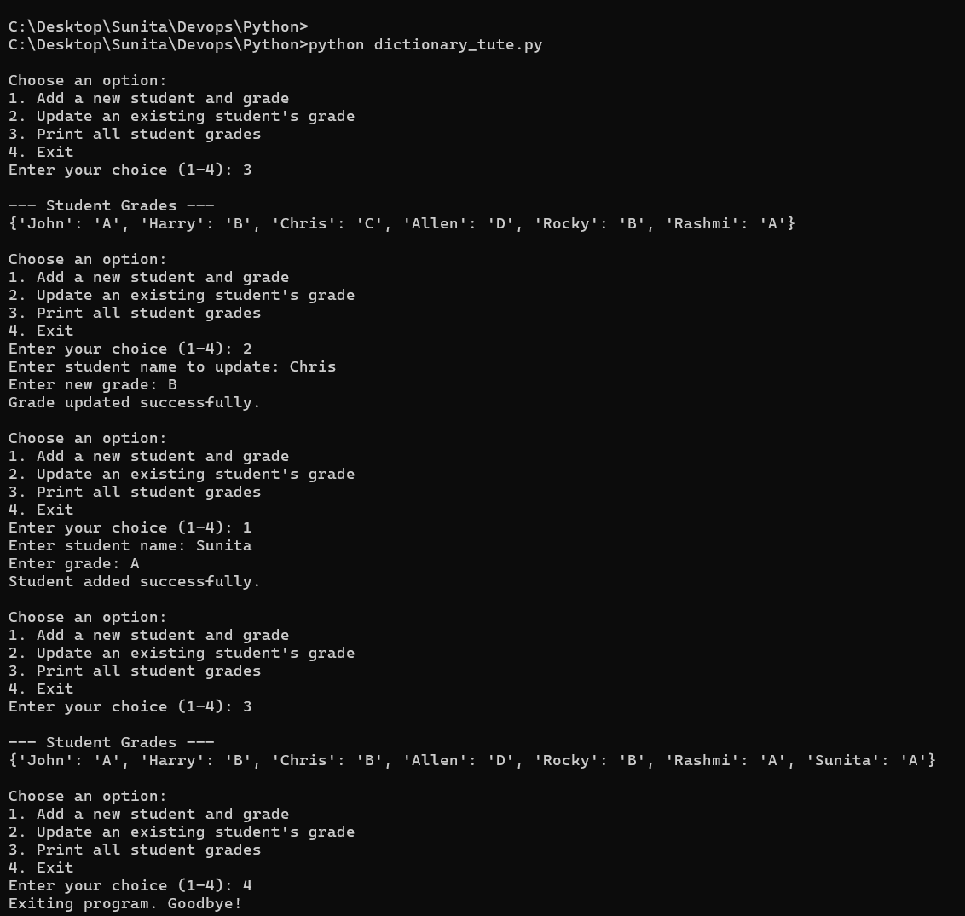

3.Write to a File
Write a program to create a text file and write some content to it.
Using file functions like write and open.
Program code:
# Create and write to a text file

# Open a file in write mode ,If the file does not exist, it will be created.
file = open("myfile.txt", "w")

# Write content to the file
file.write("Hello! This is a my sample text file.\n")
file.write("file functions used in python.\n")
file.write("adding one more line in this file.")

# Close the file
file.close()

print("Content written successfully.")
Output:
File created in local disk.

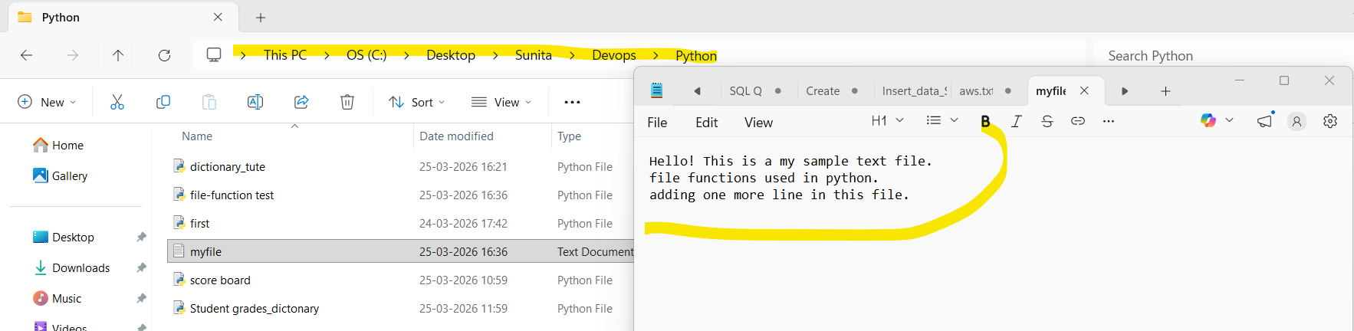

Output on terminal.

4. Read from a File
We used open in read mode and file.read to read and print to display.

# Open file in read mode
file = open("myfile.txt", "r")

# Read the content of the file
content = file.read()

# Print the content
print("File Content:")
print(content)

# Close the file
file.close()

Output:
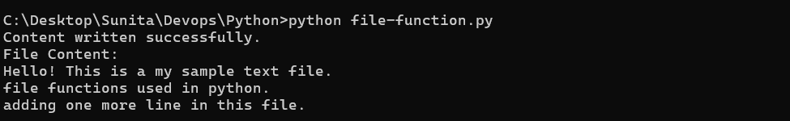
Submission Guidelines -: Attach Screenshots or command along with explanation and submit in doc(google doc or microsoft doc) format or share github link

